ASSIGNMENT-8
NAME: M.Sanjana
GROUP: CSE-AIML
COURSE: AI Assisted Coding
ENROLL NO: 2503A52709

Task Description #1 (Password Strength Validator – Apply AI in Security Context)
- Task: Apply AI to generate at least 3 assert test cases for is_strong_password(password) and implement the validator function.
- Requirements:
  - Password must have at least 8 characters.
  - Must include uppercase, lowercase, digit, and special character.
  - Must not contain spaces.
Example Assert Test Cases:
assert is_strong_password("Abcd@123") == True
assert is_strong_password("abcd123") == False
assert is_strong_password("ABCD@1234") == True
Expected Output #1:
- Password validation logic passing all AI-generated test cases.
Prompt:
Create a Python program for a Password Strength Validator using AI in a security context. Implement a function called is_strong_password(password) that returns True if the password has at least 8 characters, contains at least one uppercase letter, one lowercase letter, one digit, and one special character, and does not contain any spaces. Generate at least 3 assert test cases to verify the function, and display the expected output showing that all test cases pass.
Code:
def is_strong_password(password):
if len(password) < 8:
return False

if " " in password:
return False

has_upper = any(char.isupper() for char in password)
has_lower = any(char.islower() for char in password)
has_digit = any(char.isdigit() for char in password)
has_special = any(not char.isalnum() and char != " " for char in password)

return has_upper and has_lower and has_digit and has_special

# Assert test cases
assert is_strong_password("Abcd@123") == True
assert is_strong_password("abcd123") == False
assert is_strong_password("Abcd@1234") == True
assert is_strong_password("Abc 123@") == False
assert is_strong_password("Abcdefgh") == False

print("All AI-generated test cases passed successfully!")
Output: 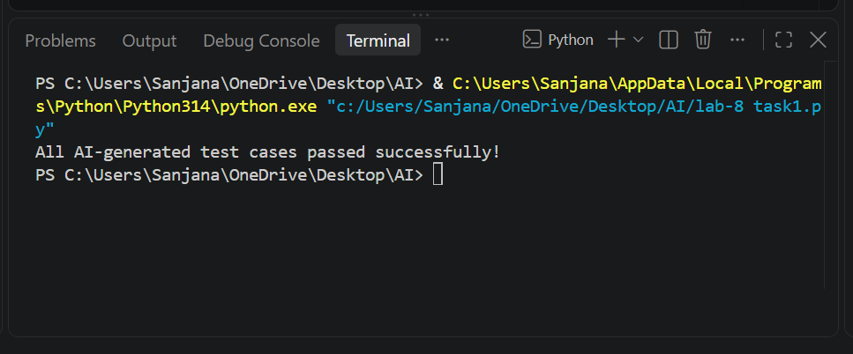

Task Description #2 (Number Classification with Loops – Apply AI for Edge Case Handling)
- Task: Use AI to generate at least 3 assert test cases for a classify_number(n) function. Implement using loops.
- Requirements:
  - Classify numbers as Positive, Negative, or Zero.
  - Handle invalid inputs like strings and None.
  - Include boundary conditions (-1, 0, 1).
Example Assert Test Cases:
assert classify_number(10) == "Positive"
assert classify_number(-5) == "Negative"
assert classify_number(0) == "Zero"
Expected Output #2:
- Classification logic passing all assert tests.
Prompt:
Create a Python program for Number Classification using loops. Implement a function named classify_number(n) that classifies numbers as "Positive", "Negative", or "Zero". The function must handle invalid inputs such as strings and None by returning "Invalid Input". Use a loop in the implementation and include boundary conditions -1, 0, and 1. Generate at least 3 assert test cases, including the given examples: assert classify_number(10) == "Positive", assert classify_number(-5) == "Negative", and assert classify_number(0) == "Zero". Also test invalid inputs and boundary values. Print a message after all assert test cases pass successfully. Provide complete Python code that can be directly run in VS Code.
Code:
def classify_number(n):
# Handle invalid inputs
if not isinstance(n, (int, float)):
return "Invalid Input"

# Use loop for classification
for i in range(1):
if n > 0:
return "Positive"
elif n < 0:
return "Negative"
else:
return "Zero"

# Assert test cases
assert classify_number(10) == "Positive"
assert classify_number(-5) == "Negative"
assert classify_number(0) == "Zero"
assert classify_number(1) == "Positive"
assert classify_number(-1) == "Negative"
assert classify_number("10") == "Invalid Input"
assert classify_number(None) == "Invalid Input"

print("All AI-generated test cases passed successfully!")
Output:
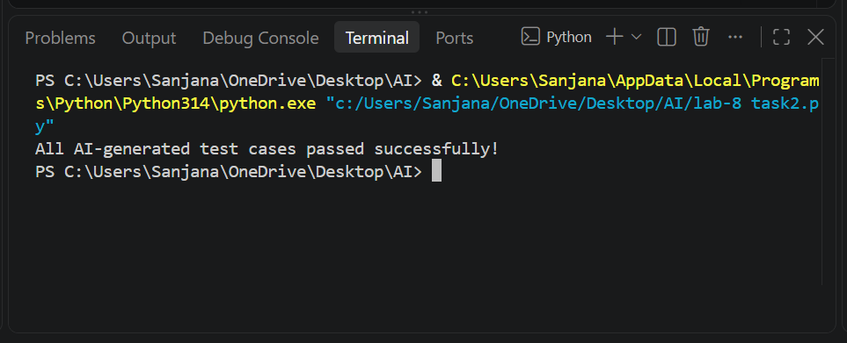

Task Description #3 (Anagram Checker – Apply AI for String Analysis)
- Task: Use AI to generate at least 3 assert test cases for is_anagram(str1, str2) and implement the function.
- Requirements:
  - Ignore case, spaces, and punctuation.
  - Handle edge cases (empty strings, identical words).
Example Assert Test Cases:
assert is_anagram("listen", "silent") == True
assert is_anagram("hello", "world") == False
assert is_anagram("Dormitory", "Dirty Room") == True
Expected Output #3:
- Function correctly identifying anagrams and passing all AI-generated tests.
Prompt:
Create a Python program to check whether two strings are anagrams. Implement a function named is_anagram(str1, str2). The function should ignore case, spaces, and punctuation. It should also handle edge cases such as empty strings and identical words. Generate at least 3 assert test cases, including "listen" and "silent", "hello" and "world", and "Dormitory" and "Dirty Room". Add additional tests for empty strings and identical words. Print a message when all assert test cases pass successfully. Provide complete Python code that can be directly run in VS Code.
Code:
def is_anagram(str1, str2):
# Ignore case, spaces, and punctuation
s1 = ""
s2 = ""

for char in str1:
if char.isalnum():
s1 += char.lower()

for char in str2:
if char.isalnum():
s2 += char.lower()

# Compare sorted characters
return sorted(s1) == sorted(s2)

# Assert test cases
assert is_anagram("listen", "silent") == True
assert is_anagram("hello", "world") == False
assert is_anagram("Dormitory", "Dirty Room") == True
assert is_anagram("", "") == True
assert is_anagram("Python", "Python") == True
assert is_anagram("The Eyes", "They See!") == True

print("All AI-generated test cases passed successfully!")
Output:
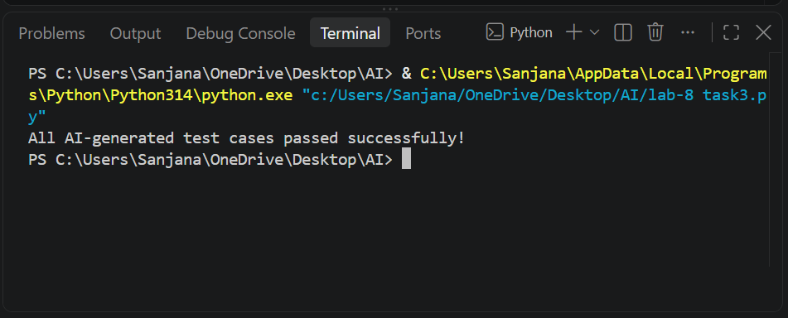

Task Description #4 (Inventory Class – Apply AI to Simulate Real-World Inventory System)
- Task: Ask AI to generate at least 3 assert-based tests for an Inventory class with stock management.
- Methods:
  - add_item(name, quantity)
  - remove_item(name, quantity)
  - get_stock(name)
Example Assert Test Cases:
inv = Inventory()
inv.add_item("Pen", 10)
assert inv.get_stock("Pen") == 10
inv.remove_item("Pen", 5)
assert inv.get_stock("Pen") == 5
inv.add_item("Book", 3)
assert inv.get_stock("Book") == 3
Expected Output #4:
- Fully functional class passing all assertions.
Prompt:
Create a Python program for an Inventory Management System using a class named Inventory. Implement the methods add_item(name, quantity), remove_item(name, quantity), and get_stock(name). Use assert-based test cases to check that items can be added, removed, and their stock can be retrieved correctly. Include at least 3 assert test cases using Pen and Book as given in the question. Also handle edge cases such as removing more items than available and checking an item that does not exist. Print a message when all assertions pass successfully. Provide complete Python code that can be directly run in VS Code.
Code:
class Inventory:
def __init__(self):
self.stock = {}

def add_item(self, name, quantity):
if quantity <= 0:
return False

self.stock[name] = self.stock.get(name, 0) + quantity
return True

def remove_item(self, name, quantity):
if quantity <= 0:
return False

if name not in self.stock or self.stock[name] < quantity:
return False

self.stock[name] -= quantity
return True

def get_stock(self, name):
return self.stock.get(name, 0)

# Assert test cases
inv = Inventory()

inv.add_item("Pen", 10)
assert inv.get_stock("Pen") == 10

inv.remove_item("Pen", 5)
assert inv.get_stock("Pen") == 5

inv.add_item("Book", 3)
assert inv.get_stock("Book") == 3

# Additional edge-case tests
assert inv.get_stock("Pencil") == 0
assert inv.remove_item("Pen", 10) == False
assert inv.add_item("Pencil", 0) == False

print("All AI-generated test cases passed successfully!")
Output:
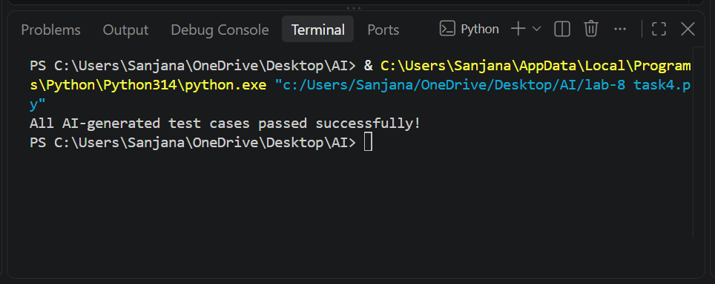

Task Description #5 (Date Validation & Formatting – Apply AI for Data Validation)
- Task: Use AI to generate at least 3 assert test cases for validate_and_format_date(date_str) to check and convert dates.
- Requirements:
  - Validate "MM/DD/YYYY" format.
  - Handle invalid dates.
  - Convert valid dates to "YYYY-MM-DD".
Example Assert Test Cases:
assert validate_and_format_date("10/15/2023") == "2023-10-15"
assert validate_and_format_date("02/30/2023") == "Invalid Date"
assert validate_and_format_date("01/01/2024") == "2024-01-01"
Expected Output #5:
- Function passes all AI-generated assertions and handles edge cases.
Prompt:
Create a Python program for Date Validation and Formatting. Implement a function named validate_and_format_date(date_str) that validates dates in the "MM/DD/YYYY" format, checks whether the date is valid, and returns "Invalid Date" for invalid dates. Convert valid dates into the "YYYY-MM-DD" format. Generate at least 3 assert test cases using these examples: assert validate_and_format_date("10/15/2023") == "2023-10-15", assert validate_and_format_date("02/30/2023") == "Invalid Date", and assert validate_and_format_date("01/01/2024") == "2024-01-01". Also include edge cases such as an incorrect date format and a leap-year date. Print a message when all assert tests pass. Provide complete Python code that can be directly run in VS Code.
Code:
from datetime import datetime

def validate_and_format_date(date_str):
try:
date = datetime.strptime(date_str, "%m/%d/%Y")
return date.strftime("%Y-%m-%d")
except ValueError:
return "Invalid Date"

# Assert test cases
assert validate_and_format_date("10/15/2023") == "2023-10-15"
assert validate_and_format_date("02/30/2023") == "Invalid Date"
assert validate_and_format_date("01/01/2024") == "2024-01-01"

# Edge cases
assert validate_and_format_date("02/29/2024") == "2024-02-29"
assert validate_and_format_date("13/01/2023") == "Invalid Date"
assert validate_and_format_date("2023/10/15") == "Invalid Date"

print("All AI-generated test cases passed successfully!")
Output:
